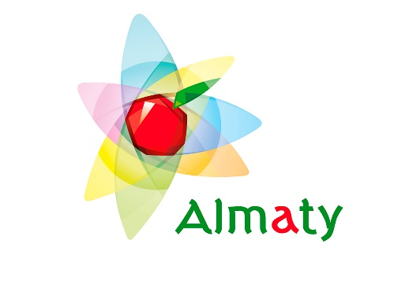

3 NIGHTS ALMATY

INCLUSIONS:

STAY
As mentioned above

TRANSPORTATION & GUIDE
- All transportation on a private basis using a 4 Str. Toyota Alphard
- Wi-Fi inside vehicles.
- Airport – hotel – airport transfers
- Vehicle available from 1000 – 2200 Hrs
- Dinner Transfers
- Sightseeing as per itinerary.
- Dedicated English speaking Driver cum Guide during the tours
- 2 X 500 ML water bottles per person in the vehicle daily.
- Refreshing napkins & chocolate inside the vehicle upon arrival
- Departure souvenir gift.

ENTRANCE & ACTIVITIES
- Shymbulak Gondola tickets – L1,2,3 (return)
- Kok Tobe Gondola tickets – Return

MEALS
- Breakfast at the hotel

SHORT ITINERARY
Day wise Itinerary - 3 Nights - 4 Days
Day 1 - Arrival at ALMATY
Day 2 - Visit the Shymbulak Ski resort – Level 3 via Gondola + Panfilov & Arbat walking tour
Day 3 - Almaty city tour + Panfilov Park & Zenkov Cathedral + Visit to Kok Tobe Hill
Day 4 - Departure from ALMATY - Drop to Airport

EXCLUSIONS:
1. Extra excursions. Any expenditure of Personal nature. E.g., Laundry, Tips, phone calls etc.
2. Meals, unless or otherwise specified in the above quote.
3. Anything not mentioned above
4. Entrance charges to Nightclubs, monuments etc.
5. Consumption of food & beverages at Nightclub/s.
6. Beverage consumption during lunches & dinner.
7. Refundable security deposit (U$ 100 Per Room) at the time of check-in in the hotel.

